1. How and when to use the AutoSum command in excel?

Ans

If you need to sum a column or row of numbers, let Excel do the math for you. Select a cell next to the numbers you want to sum, click **AutoSum** on the **Home** tab, press **Enter**, and you’re done.

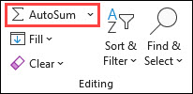

When you click **AutoSum**, Excel automatically enters a formula (that uses the [SUM function](https://support.microsoft.com/en-us/office/sum-function-043e1c7d-7726-4e80-8f32-07b23e057f89)) to sum the numbers.

Here’s an example. To add the January numbers in this Entertainment budget, select cell B7, the cell immediately below the column of numbers. Then click **AutoSum**. A formula appears in cell B7, and Excel highlights the cells you’re totaling.

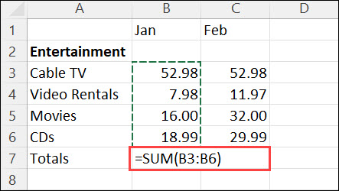

Press Enter to display the result (95.94) in cell B7. You can also see the formula in the formula bar at the top of the Excel window.

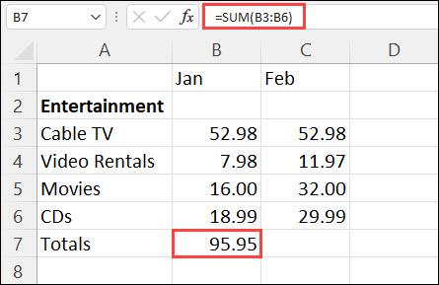

**Notes:**

* To sum a column of numbers, select the cell immediately below the last number in the column. To sum a row of numbers, select the cell immediately to the right.
* **AutoSum** is in two locations: **Home** > **AutoSum**, and **Formulas** > **AutoSum**.
* Once you create a formula, you can copy it to other cells instead of typing it over and over. For example, if you copy the formula in cell B7 to cell C7, the formula in C7 automatically adjusts to the new location, and calculates the numbers in C3:C6.
* You can also use AutoSum on more than one cell at a time. For example, you could highlight both cell B7 and C7, click **AutoSum**, and total both columns at the same time.

1. What is the shortcut key to perform AutoSum?

Ans

**The Autosum Excel shortcut is very simple – just type two keys:**

1. ALT =
2. Step 1: place the cursor below the column of numbers you want to sum (or to the left of the row of numbers you want to sum).
3. Step 2: hold down the Alt key and then press the equals = sign while still holding Alt.
4. Step 3: press Enter.
5. How do you get rid of Formula that omits adjacent cells?

Ans

**To turn off the notification "Formula Omits Adjacent Cells" you're getting, kindly follow the steps below:**

1. Open Excel and then click on File.
2. Go to Options and then select Formulas.
3. Look for Error checking rules and uncheck Formulas which omit cells in a region.
4. Click OK.
   1. How do you select non-adjacent cells in Excel 2016?

Ans

Select Non-Adjacent Cells with Keyboard and Mouse

1. With your mouse, click the first cell you want to highlight. This cell becomes the [active cell](https://www.lifewire.com/active-cell-definition-3123375).
2. Press and hold the **Ctrl**key on the keyboard.
3. Click the rest of the cells you want to highlight.
4. Once the desired cells are highlighted, release the**Ctrl**key.
5. Do not click anywhere else with the mouse pointer once you release the **Ctrl** key or you will clear the highlight from the selected cells.
6. If you release the **Ctrl** key too soon and wish to highlight more cells, press and hold the **Ctrl** key again and click the additional cell(s).

5. What happens if you choose a column, hold down the Alt key and press the letters

ocw in quick succession?

6. If you right-click on a row reference number and click on Insert, where will the row

be added?

Ans

### **Insert or delete a column**

1. Select any cell within the column, then go to **Home** > **Insert** > **Insert Sheet Columns**or **Delete Sheet Columns**.
2. Alternatively, right-click the top of the column, and then select **Insert** or **Delete**.

### **Insert or delete a row**

1. Select any cell within the row, then go to **Home** > **Insert** > **Insert Sheet Rows**or **Delete Sheet Rows**.
2. Alternatively, right-click the row number, and then select **Insert** or **Delete**.

### **Formatting options**

When you select a row or column that has formatting applied, that formatting will be transferred to a new row or column that you insert. If you don't want the formatting to be applied, you can select the **Insert Options** button after you insert, and choose from one of the options as follows:

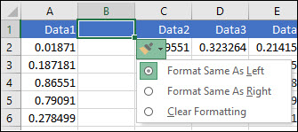

If the Insert Options button isn't visible, then go to **File** > **Options** > **Advanced** > in the **Cut, copy and paste** group, check the **Show Insert Options buttons** option.